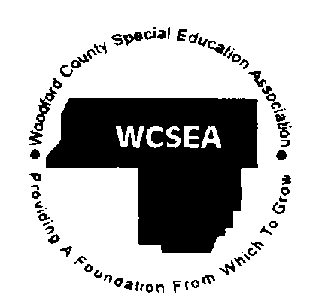  Eric Scroggs, Executive Director  Date: June 10, 2015  To: WCSEA Superintendents  From: Eric Scroggs, Director | Woodford County Special Education Association  205 S. Engelwood Drive  Metamora, Illinois 61548 | Phone (309) 367-4901  Fax (309) 367-4905  E-Mail escroggs@wcsea.us
2015-16 WCSEA Executive Committee Meetings
WCSEA Board Room
8:00 AM – 9:00 AM

August 6, 2015*
September 10, 2015 Budget Hearing
October 8, 2015
November 5, 2015*
December 10, 2015
January 7, 2016*
February 4, 2016*
March 10, 2016
April 14, 2016
May 5, 2016*
June 9, 2016

*Date changed from 2nd Thursday

